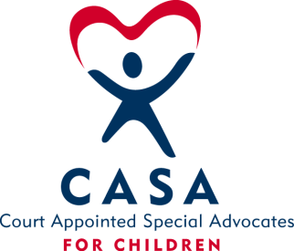

Nebraska CASA Champion Program

Overview
We are looking for one Nebraskan to be our CASA volunteer spokesperson. They will receive the title 2022 Nebraska CASA Champion. We are asking for them to work with the Grow Nebraska CASA committee on creative ideas for recruitment of volunteers and fundraising. They may speak at local and statewide CASA events online or in person. They will speak at the state conference on Aug. 27th. The Champion will utilize their own social media and networks to share stories and promotions of CASA volunteer recruitment.
The Champion will work with their immediate community and sphere of influence to raise the visibility of the organization and its mission. Pursuing duties, such as those listed below, that play to their own individual strengths and abilities. The Champion will work to advance the common good of our statewide communities through the framework provided by the Nebraska CASA Association.
Vision of Nebraska CASA Association
Ensure that all local CASA programs provide a CASA volunteer to every child who needs one.
Mission
Create awareness of CASA in Nebraska to increase the number of volunteers signing up and raise funds for supporting those volunteers.
Nebraska CASA Association is a network of 21 local programs in Nebraska serving 52 counties. We recruit, screen, train, and support Court Appointed Special Advocates. Those advocates are volunteers just like you-who are appointed by a judge to speak for the wellbeing of abused and neglected children.
Goal #1: 237 new CASA volunteers recruited, screened, and trained in Nebraska in 2022.
Goal #2: Raise funds for recruitment of volunteers in Nebraska in 2022.
Goal #3: Add 5 new businesses promoting CASA statewide in Nebraska in 2022.
Champion Qualifications:
Must be at least 19 years old,
Has a history of CASA involvement
Comfortable telling your story on many platforms (ie Public Speaking, social media, TV ads and Radio)
Organized, and effective communicator and enjoys community engagement.
Exhibit energy and passion for the CASA Association
Top 5 applicants will undergo a background check as well as submit a 5 min video (explaining his/her vision and personal goal for the growth of the NE CASA Association). Undergo an informal interview and complete a two-hour training.
Expectations:
Commit to a year of being the Champion for Nebraska CASA.
Attend the Nebraska CASA Conference on August 27, 2022 and give speech.
Attend short (possibly 15-minute) meetings with local program directors via Zoom or in person 4 times per year.
Set and reach his or her personal goal for the growth of NE CASA Association with the assistance of the Grow NE CASA committee.
To spend no more than 20 hours a month dedicated to above mentioned goal completion.
NE CASA Champion will actively work with the GROW NE CASA Committee.
Participate in monthly zoom meetings with the committee.
Work with committee to produce recording of his/her story.
Work with committee to produce recording of cliff hangers.
Work with committee to set up and or make presentations at organized community events recruiting local CASA volunteers. Events may be virtual, if not, local programs may be asked to help fund transportation costs.
Share CASA events and news on their own social media.

2 ways to submit your nominee’s application!
By mail:
Nebraska CASA Association
3701 Sumner Street Lincoln, NE 68506
Or
By Email:
Necasa.corrie@gmail.com *Please make subject line NE CASA Champion Application

DEADLINE – DECEMBER 10, 2021

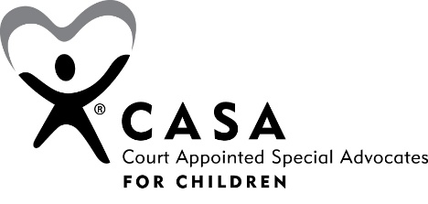

2022 Nebraska CASA Champion – Nomination Form

Nominated by: __________________________________ Date: _______________
Address: ________________________ City: _______________ Zip: ___________
Phone: _______________________ Email: _______________________________

General Information about the Nominee

Nominee Name: _____________________________________________________
Address: ________________________ City: _______________ Zip: ___________
Phone: _______________________ Email: _______________________________

Is he/she currently employed? _________ Job Title: ________________________
Company/Organization: ______________________________________________
Does the nominee have your permission to be nominated? _______________________

Criminal background check and child/adult abuse registry check will be conducted on the chosen 2022 Nebraska CASA Champion.

Community and Organization Experience

Share innovative work and/or achievements of the nominee related to children’s issues and why he/she should be honored.

What is the nominee’s history with CASA?

What challenges has the nominee had to overcome to accomplish their goals? How have they inspired others?

How has the nominee’s achievements exemplified CASA values and the vision to make the lives of children better?

Briefly describe why the nominee should become the Nebraska CASA Champion of the Year for 2022?

In what capacity have you known the applicant?

How well do you know the applicant? (insert and X in box)

Very Well Well Average Little Very Little

Describe the applicant’s ability to dedicate their time from January to December of 2022.

Excellent Good Average Fair Poor

Briefly describe your overall impression of the nominee’s ability to foster the NE CASA Association goal to have a CASA for every child who needs one in Nebraska.

